banking_core | SBP
V1.0

Revision History
Version | Date | Description | Author
1.0 | 18/02/2026 | Initial Version | Mohammed Megahed

Reviewers
# | Name | Position | Date and Signature
1
2

Acceptance and Signoff
# | Name | Position | Date and Signature
1
2

Contents
1. Introduction 4
1.1. Project Summary 4
1.2. In-Scope 4
1.3. Out-Scope 4
1.4. Target Audience 4
1.5. Abbreviations 4
1.6. Assumptions, Dependencies and Risks 4
2. Requirements Compliancy Matrix 5
3. Solution Architecture 6
3.1. Solution Description 6
3.2. Non-Functional Requirements 6
3.3. Security Considerations 6
4. Account Opening Flow 7
4.1. Sequence Diagram 7
4.2. Flow Description 8
4.3. APIs Contract Agreement 11
4.4. Error Handling 12
5. Instant Fund Transfer via SARIE 19
5.1. Sequence Diagram 19
5.2. Flow Description 20
5.3. APIs Contract Agreement 21
6. Personal Loan Disbursement 23
6.1. Sequence Diagram 23
6.2. Flow Description 25
6.3. APIs Contract Agreement 26
7. Appendix 29
7.1. Solution Architecture Reference Documents 29

1. Introduction

1.1. Project Summary
This project builds a modern core banking system to replace legacy systems, focusing on customer onboarding, account management, deposits, and real-time transactions. Key capabilities include automated onboarding, real-time balances, multi-currency support, and a comprehensive 360-degree customer view. This transforms digital banking, enabling seamless customer interactions and real-time financial insights.

1.2. In-Scope
# | Item
1. | Customer onboarding (individual and corporate)
2. | Account management (Current, Savings, Term Deposit)
3. | Cash deposits and withdrawals
4. | Internal fund transfers
5. | Domestic transfers via SARIE
6. | International transfers via SWIFT
7. | Personal loan origination and disbursement

1.3. Out-Scope
# | Item
1. | Credit card management
2. | Trade finance operations
3. | Treasury and investment banking
4. | Islamic banking products

1.4. Target Audience
# | Stakeholders
1. | Enterprise Architects
2. | Partners and Vendors Technical Leaders
3. | Infrastructure Architects & Engineers
4. | InfoSec Architects & Engineers
5. | Technical Managers
6. | Delivery Leads and Project Managers
7. | Developers

1.5. Abbreviations
# | Abbreviations | Full form
1

1.6. Assumptions, Dependencies and Risks
# | Item | Type | Owner | Comment
1.
2.

2. Requirements Compliancy Matrix
ID. | Title | Description | Compliancy | Comments
FR-1 | CoreBank is a modern core banking system replacing legacy mainframe systems with | This requirement enables corebank is a modern core banking system replacing legacy mainframe systems with functionality for users. | Compliant
FR-2 | The platform supports retail banking operations including account management, de | This requirement enables the platform supports retail banking operations including account management, de functionality for users. | Compliant
FR-3 | Real-time processing and Open Banking APIs enable digital transformation | This requirement enables real-time processing and open banking apis enable digital transformation functionality for users. | Compliant
FR-BR-001 | Customer Onboarding | This requirement enables customer onboarding functionality for users. | Compliant
FR-BR-002 | View | This requirement enables view functionality for users. | Compliant
FR-BR-003 | Account Types | This requirement enables account types functionality for users. | Compliant
FR-BR-004 | Multi-Currency | This requirement enables multi-currency functionality for users. | Compliant
FR-BR-005 | Real-time Balance | This requirement enables real-time balance functionality for users. | Compliant
FR-BR-006 | ransfer | This requirement enables ransfer functionality for users. | Compliant
FR-BR-007 | ransfer | This requirement enables ransfer functionality for users. | Compliant
FR-BR-008 | Loan Origination | This requirement enables loan origination functionality for users. | Compliant
FR-BR-009 | alculation | This requirement enables alculation functionality for users. | Compliant
FR-BR-010 | osting | This requirement enables osting functionality for users. | Compliant

3. Solution Architecture

3.1. Solution Description
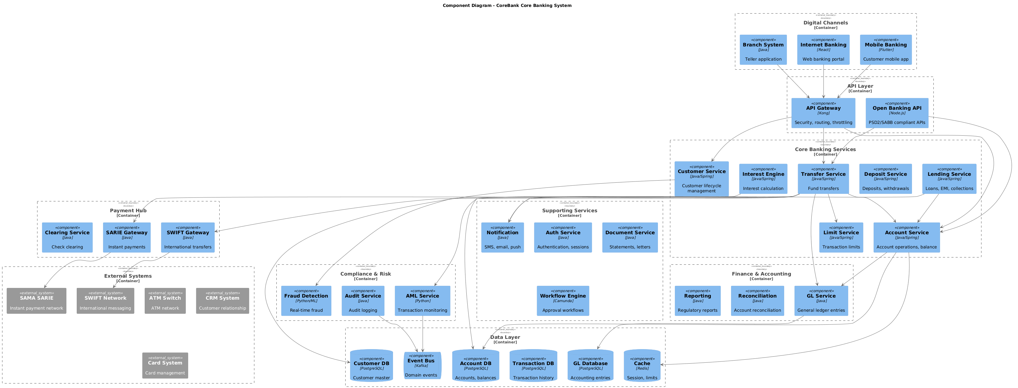

3.2. Non-Functional Requirements
# | Category | Requirement | Target/SLA
1 | Performance | API Response Time | < 2 seconds for 95th percentile
2 | Performance | Transaction Throughput | Support 100 TPS during peak hours
3 | Availability | System Uptime | 99.9% availability (excluding planned maintenance)
4 | Availability | Recovery Time Objective (RTO) | < 4 hours
5 | Availability | Recovery Point Objective (RPO) | < 1 hour
6 | Scalability | Horizontal Scaling | Support auto-scaling based on load
7 | Scalability | Concurrent Users | Support 1000 concurrent users
8 | Data Retention | Transaction Logs | Retain for 7 years as per regulatory requirements
9 | Data Retention | Audit Logs | Retain for 5 years
10 | Compliance | Regulatory | Comply with CMA and SAMA regulations
11 | Compliance | Data Protection | Comply with data privacy requirements

3.3. Security Considerations
# | Security Domain | Requirement | Implementation
1 | Authentication | User Authentication | OAuth 2.0 / JWT tokens with secure token storage
2 | Authentication | Service-to-Service Auth | Mutual TLS (mTLS) for internal service communication
3 | Authentication | Multi-Factor Authentication | MFA required for sensitive operations
4 | Authorization | Role-Based Access Control | RBAC implemented with principle of least privilege
5 | Authorization | API Authorization | Scope-based access control for API endpoints
6 | Data Protection | Data in Transit | TLS 1.2+ encryption for all network communication
7 | Data Protection | Data at Rest | AES-256 encryption for sensitive data storage
8 | Data Protection | PII/Sensitive Data | Data masking and tokenization for sensitive fields
9 | API Security | Input Validation | Server-side validation of all input parameters
10 | API Security | Rate Limiting | Rate limiting to prevent abuse and DDoS attacks
11 | API Security | CORS Policy | Strict CORS policy for web API endpoints
12 | Audit & Logging | Audit Trail | Log all security-relevant events with timestamps
13 | Audit & Logging | Log Protection | Immutable logs with tamper detection
14 | Vulnerability Management | Security Scanning | Regular SAST/DAST scanning in CI/CD pipeline
15 | Vulnerability Management | Dependency Scanning | Automated scanning for vulnerable dependencies

4. Account Opening Flow

4.1. Sequence Diagram
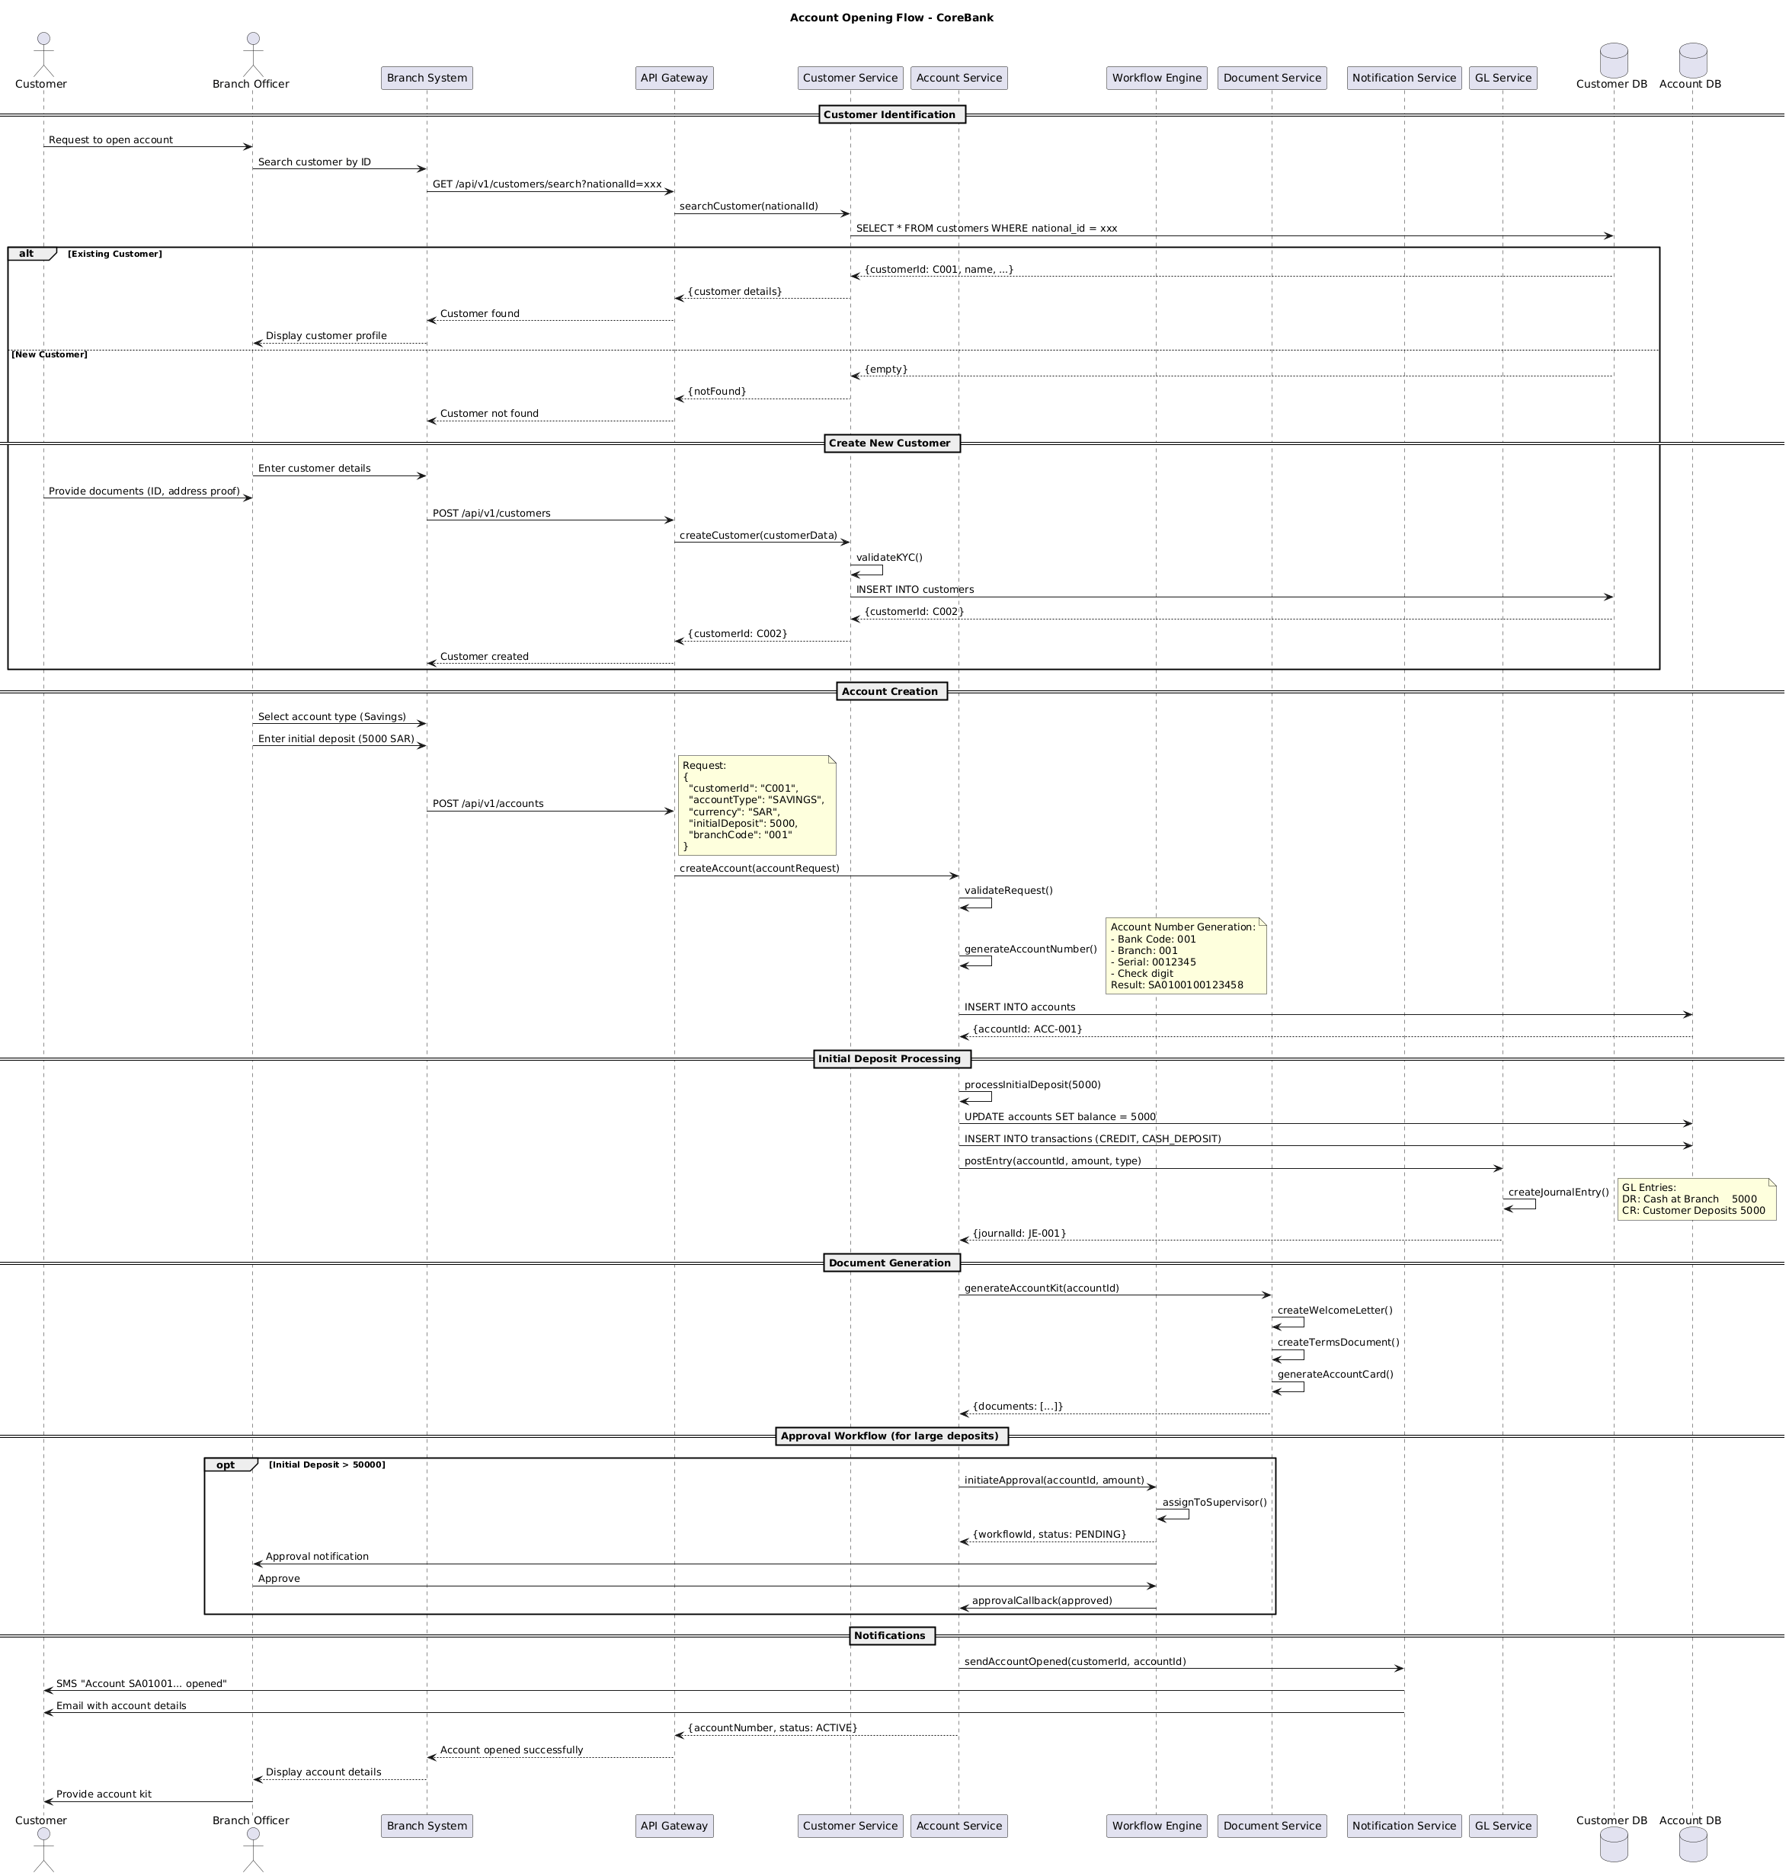

4.2. Flow Description
Customer Identification
• The customer requests to open an account, which triggers a search for the customer by ID.
• The system queries the Customer Service for customer details based on the provided national ID.
• If the customer is found (existing customer), the system displays the customer profile.
• If the customer is not found (new customer), the system creates a new customer record and prompts for document submission.
Create New Customer
• The branch officer enters customer details and requests documents (ID and address proof).
• The system creates a new customer record in the Customer DB and validates KYC.
• The system inserts the new customer record into the Customer DB.
• The system creates account documents such as account kit, welcome letter, and terms document.
Account Creation
• The branch officer selects the account type and initial deposit amount.
• The system creates an account in the Account DB and generates an account number.
• The system processes the initial deposit and updates the account balance in the Account DB.
• The system posts the initial deposit transaction to the GL Service.
Initial Deposit Processing
• The system processes the initial deposit, updating the account balance in the Account DB.
• The system posts the transaction to the GL Service.
• The system generates GL entries for the initial deposit.
Document Generation
• The system generates account documents such as account kit, welcome letter, and terms document.
Approval Workflow (for large deposits)
• For initial deposits exceeding 50,000 SAR, the system initiates an approval workflow.
• The workflow engine assigns the approval to a supervisor.
• The branch officer approves the initial deposit.
• The system updates the approval status in the workflow engine.
Notifications
• The system sends notifications to the customer via SMS and email.
• The system updates the API Gateway with the account number and status.
• The branch system displays the account details to the customer and provides the account kit.
  - Authentication & Validation
• The system internally handles customer identification by querying the Customer DB and validating the customer details.
• The system internally validates KYC for new customers and updates the Customer DB.
• The system internally generates account numbers and updates the Account DB.
• The system internally processes initial deposits and updates the Account DB and GL Service.
• The system internally handles document generation and updates the Document Service.
• The system internally handles approval workflows and updates the Workflow Engine.
• The system internally handles notifications and updates the Notification Service.
  - Notes
Note 1 (section: Account Creation)
Request
• {
"customerId": "C001",
"accountType": "SAVINGS",
"currency": "SAR",
"initialDeposit": 5000,
"branchCode": "001"
}
Note 2 (section: Account Creation)
Account Number Generation
• Bank Code: 001
• Branch: 001
• Serial: 0012345
• Check digit
Result: SA0100100123458
Note 3 (section: Initial Deposit Processing)
GL Entries
• DR: Cash at Branch 5000
• CR: Customer Deposits 5000
  - Self-Interactions
• Customer internally searches for the customer by ID.
• Customer internally creates a new customer record if necessary.
• Customer internally validates KYC for new customers.
• Customer internally inserts the new customer record into the Customer DB.
• Customer internally generates account numbers and updates the Account DB.
• Customer internally processes initial deposits and updates the Account DB and GL Service.
• Customer internally generates account documents and updates the Document Service.
• Customer internally handles approval workflows and updates the Workflow Engine.
• Customer internally sends notifications and updates the Notification Service.
  - Control Structures & Conditions
• Conditional branching: If the customer is found (existing customer), the system displays the customer profile. If the customer is not found (new customer), the system creates a new customer record and prompts for document submission.
• Optional execution paths: For initial deposits exceeding 50,000 SAR, the system initiates an approval workflow.
• Repetitive behavior: The system repeats the process of processing the initial deposit and updating the GL Service for each transaction.
• Parallel execution: In parallel, the system performs document generation and approval workflows.
• Protected or synchronized execution: Within a protected execution scope, the system handles customer identification, account creation, and initial deposit processing.
• Early termination paths: The flow terminates early when the customer is found (existing customer) or when the initial deposit exceeds 50,000 SAR.
• Logical grouping or phases: The flow is divided into logical phases such as customer identification, account creation, initial deposit processing, document generation, approval workflow, and notifications.
  - Alternative & Conditional Flows
• Alt: If the customer is found (existing customer), the system displays the customer profile. If the customer is not found (new customer), the system creates a new customer record and prompts for document submission.
• Opt (when: Initial Deposit > 50,000 SAR): If the initial deposit exceeds 50,000 SAR, the system initiates an approval workflow, assigns it to a supervisor, and the branch officer approves the initial deposit.

4.3. APIs Contract Agreement
# | Source | Destination | API | Protocol | Request Parameters | Response Parameters
1 | Branch System | API Gateway | GET /api/v1/customers/search?nationalId=xxx | REST |  | Customer found
2 | API Gateway | Customer Service | searchCustomer | REST | nationalId | {customer details}
3 | Branch System | API Gateway | POST /api/v1/customers | REST |  | Customer created
4 | API Gateway | Customer Service | createCustomer | REST | customerData | {customerId: C002}
5 | Branch System | API Gateway | POST /api/v1/accounts | REST |  | Account opened successfully
6 | API Gateway | Account Service | createAccount | REST | accountRequest | {accountNumber, status: ACTIVE}
7 | Account Service | Account DB | INSERT INTO accounts | JDBC |  | {accountId: ACC-001}
8 | Account Service | Account DB | UPDATE accounts SET balance = 5000 | JDBC
9 | Account Service | Account DB | INSERT INTO transactions | JDBC | CREDIT, CASH_DEPOSIT
10 | Account Service | GL Service | postEntry | REST | accountId, amount, type | {journalId: JE-001}
11 | Account Service | Document Service | generateAccountKit | REST | accountId | {documents: [...]}
12 | Account Service | Workflow Engine | initiateApproval | REST | accountId, amount | {workflowId, status: PENDING}
13 | Workflow Engine | Branch Officer | Approval notification | REST
14 | Workflow Engine | Account Service | approvalCallback | REST | approved
15 | Account Service | Notification Service | sendAccountOpened | REST | customerId, accountId
16 | Notification Service | Customer | SMS "Account SA01001... opened" | REST
17 | Notification Service | Customer | Email with account details | REST
[*] Indicates that the data element is optional

4.4. Error Handling
# | Source | Destination | Scenario | Handling
1 | "Branch System" | "API Gateway" | createAccount  Duplicate request for account creation | Ensure idempotency to avoid duplicates on retry; Log error with correlation ID; Queue request for asynchronous retry; Notify user of failure
2 | "Customer Service" | "Account Service" | validateKYC  Customer KYC validation failure | Ensure idempotency to avoid duplicates on retry; Log error with correlation ID; Queue request for asynchronous retry; Notify user of failure
3 | "Account Service" | "Account Database" | generateAccountNumber  Account number generation failure | Ensure idempotency to avoid duplicates on retry; Log error with correlation ID; Queue request for asynchronous retry; Notify user of failure
4 | "Account Service" | "Account Database" | updateAccountBalance  Update account balance failure | Ensure idempotency to avoid duplicates on retry; Log error with correlation ID; Queue request for asynchronous retry; Notify user of failure
5 | "Account Service" | "Account Database" | insertTransaction  Insert transaction failure | Ensure idempotency to avoid duplicates on retry; Log error with correlation ID; Queue request for asynchronous retry; Notify user of failure
6 | "Account Service" | "GL Service" | postEntry  GL entry posting failure | Ensure idempotency to avoid duplicates on retry; Log error with correlation ID; Queue request for asynchronous retry; Notify user of failure
7 | "Account Service" | "Document Service" | generateAccountKit  Generate account kit failure | Ensure idempotency to avoid duplicates on retry; Log error with correlation ID; Queue request for asynchronous retry; Notify user of failure
8 | "Account Service" | "Document Service" | createWelcomeLetter  Create welcome letter failure | Ensure idempotency to avoid duplicates on retry; Log error with correlation ID; Queue request for asynchronous retry; Notify user of failure
9 | "Account Service" | "Document Service" | createTermsDocument  Create terms document failure | Ensure idempotency to avoid duplicates on retry; Log error with correlation ID; Queue request for asynchronous retry; Notify user of failure
10 | "Account Service" | "Document Service" | generateAccountCard  Generate account card failure | Ensure idempotency to avoid duplicates on retry; Log error with correlation ID; Queue request for asynchronous retry; Notify user of failure
11 | "Account Service" | "Notification Service" | sendAccountOpened  Send account opened notification failure | Ensure idempotency to avoid duplicates on retry; Log error with correlation ID; Queue request for asynchronous retry; Notify user of failure
12 | "Account Service" | "Customer Service" | approvalCallback  Approval callback failure | Ensure idempotency to avoid duplicates on retry; Log error with correlation ID; Queue request for asynchronous retry; Notify user of failure
13 | "Account Service" | "Customer Service" | sendAccountOpened  Customer notification failure | Ensure idempotency to avoid duplicates on retry; Log error with correlation ID; Queue request for asynchronous retry; Notify user of failure
14 | "Account Service" | "Customer Service" | sendAccountOpened  Customer notification repeated failure | Ensure idempotency to avoid duplicates on retry; Log error with correlation ID; Queue request for asynchronous retry; Notify user of failure
15 | "Account Service" | "Customer Service" | sendAccountOpened  Customer notification repeated failure | Ensure idempotency to avoid duplicates on retry; Log error with correlation ID; Queue request for asynchronous retry; Notify user of failure
16 | "Account Service" | "Customer Service" | sendAccountOpened  Customer notification repeated failure | Ensure idempotency to avoid duplicates on retry; Log error with correlation ID; Queue request for asynchronous retry; Notify user of failure
17 | "Account Service" | "Customer Service" | sendAccountOpened  Customer notification repeated failure | Ensure idempotency to avoid duplicates on retry; Log error with correlation ID; Queue request for asynchronous retry; Notify user of failure
18 | "Account Service" | "Customer Service" | sendAccountOpened  Customer notification repeated failure | Ensure idempotency to avoid duplicates on retry; Log error with correlation ID; Queue request for asynchronous retry; Notify user of failure
19 | "Account Service" | "Customer Service" | sendAccountOpened  Customer notification repeated failure | Ensure idempotency to avoid duplicates on retry; Log error with correlation ID; Queue request for asynchronous retry; Notify user of failure
20 | "Account Service" | "Customer Service" | sendAccountOpened  Customer notification repeated failure | Ensure idempotency to avoid duplicates on retry; Log error with correlation ID; Queue request for asynchronous retry; Notify user of failure
21 | "Account Service" | "Customer Service" | sendAccountOpened  Customer notification repeated failure | Ensure idempotency to avoid duplicates on retry; Log error with correlation ID; Queue request for asynchronous retry; Notify user of failure
22 | "Account Service" | "Customer Service" | sendAccountOpened  Customer notification repeated failure | Ensure idempotency to avoid duplicates on retry; Log error with correlation ID; Queue request for asynchronous retry; Notify user of failure
23 | "Account Service" | "Customer Service" | sendAccountOpened  Customer notification repeated failure | Ensure idempotency to avoid duplicates on retry; Log error with correlation ID; Queue request for asynchronous retry; Notify user of failure
24 | "Account Service" | "Customer Service" | sendAccountOpened  Customer notification repeated failure | Ensure idempotency to avoid duplicates on retry; Log error with correlation ID; Queue request for asynchronous retry; Notify user of failure
25 | "Account Service" | "Customer Service" | sendAccountOpened  Customer notification repeated failure | Ensure idempotency to avoid duplicates on retry; Log error with correlation ID; Queue request for asynchronous retry; Notify user of failure
26 | "Account Service" | "Customer Service" | sendAccountOpened  Customer notification repeated failure | Ensure idempotency to avoid duplicates on retry; Log error with correlation ID; Queue request for asynchronous retry; Notify user of failure
27 | "Account Service" | "Customer Service" | sendAccountOpened  Customer notification repeated failure | Ensure idempotency to avoid duplicates on retry; Log error with correlation ID; Queue request for asynchronous retry; Notify user of failure
28 | "Account Service" | "Customer Service" | sendAccountOpened  Customer notification repeated failure | Ensure idempotency to avoid duplicates on retry; Log error with correlation ID; Queue request for asynchronous retry; Notify user of failure
29 | "Account Service" | "Customer Service" | sendAccountOpened  Customer notification repeated failure | Ensure idempotency to avoid duplicates on retry; Log error with correlation ID; Queue request for asynchronous retry; Notify user of failure
30 | "Account Service" | "Customer Service" | sendAccountOpened  Customer notification repeated failure | Ensure idempotency to avoid duplicates on retry; Log error with correlation ID; Queue request for asynchronous retry; Notify user of failure
31 | "Account Service" | "Customer Service" | sendAccountOpened  Customer notification repeated failure | Ensure idempotency to avoid duplicates on retry; Log error with correlation ID; Queue request for asynchronous retry; Notify user of failure
32 | "Account Service" | "Customer Service" | sendAccountOpened  Customer notification repeated failure | Ensure idempotency to avoid duplicates on retry; Log error with correlation ID; Queue request for asynchronous retry; Notify user of failure
33 | "Account Service" | "Customer Service" | sendAccountOpened  Customer notification repeated failure | Ensure idempotency to avoid duplicates on retry; Log error with correlation ID; Queue request for asynchronous retry; Notify user of failure
34 | "Account Service" | "Customer Service" | sendAccountOpened  Customer notification repeated failure | Ensure idempotency to avoid duplicates on retry; Log error with correlation ID; Queue request for asynchronous retry; Notify user of failure
35 | "Account Service" | "Customer Service" | sendAccountOpened  Customer notification repeated failure | Ensure idempotency to avoid duplicates on retry; Log error with correlation ID; Queue request for asynchronous retry; Notify user of failure
36 | "Account Service" | "Customer Service" | sendAccountOpened  Customer notification repeated failure | Ensure idempotency to avoid duplicates on retry; Log error with correlation ID; Queue request for asynchronous retry; Notify user of failure
37 | "Account Service" | "Customer Service" | sendAccountOpened  Customer notification repeated failure | Ensure idempotency to avoid duplicates on retry; Log error with correlation ID; Queue request for asynchronous retry; Notify user of failure
38 | "Account Service" | "Customer Service" | sendAccountOpened  Customer notification repeated failure | Ensure idempotency to avoid duplicates on retry; Log error with correlation ID; Queue request for asynchronous retry; Notify user of failure
39 | "Account Service" | "Customer Service" | sendAccountOpened  Customer notification repeated failure | Ensure idempotency to avoid duplicates on retry; Log error with correlation ID; Queue request for asynchronous retry; Notify user of failure
40 | "Account Service" | "Customer Service" | sendAccountOpened  Customer notification repeated failure | Ensure idempotency to avoid duplicates on retry; Log error with correlation ID; Queue request for asynchronous retry; Notify user of failure
41 | "Account Service" | "Customer Service" | sendAccountOpened  Customer notification repeated failure | Ensure idempotency to avoid duplicates on retry; Log error with correlation ID; Queue request for asynchronous retry; Notify user of failure
42 | "Account Service" | "Customer Service" | sendAccountOpened  Customer notification repeated failure | Ensure idempotency to avoid duplicates on retry; Log error with correlation ID; Queue request for asynchronous retry; Notify user of failure
43 | "Account Service" | "Customer Service" | sendAccountOpened  Customer notification repeated failure | Ensure idempotency to avoid duplicates on retry; Log error with correlation ID; Queue request for asynchronous retry; Notify user of failure
44 | "Account Service" | "Customer Service" | sendAccountOpened  Customer notification repeated failure | Ensure idempotency to avoid duplicates on retry; Log error with correlation ID; Queue request for asynchronous retry; Notify user of failure
45 | "Account Service" | "Customer Service" | sendAccountOpened  Customer notification repeated failure | Ensure idempotency to avoid duplicates on retry; Log error with correlation ID; Queue request for asynchronous retry; Notify user of failure
46 | "Account Service" | "Customer Service" | sendAccountOpened  Customer notification repeated failure | Ensure idempotency to avoid duplicates on retry; Log error with correlation ID; Queue request for asynchronous retry; Notify user of failure
47 | "Account Service" | "Customer Service" | sendAccountOpened  Customer notification repeated failure | Ensure idempotency to avoid duplicates on retry; Log error with correlation ID; Queue request for asynchronous retry; Notify user of failure
48 | "Account Service" | "Customer Service" | sendAccountOpened  Customer notification repeated failure | Ensure idempotency to avoid duplicates on retry; Log error with correlation ID; Queue request for asynchronous retry; Notify user of failure
49 | "Account Service" | "Customer Service" | sendAccountOpened  Customer notification repeated failure | Ensure idempotency to avoid duplicates on retry; Log error with correlation ID; Queue request for asynchronous retry; Notify user of failure
50 | "Account Service" | "Customer Service" | sendAccountOpened  Customer notification repeated failure | Ensure idempotency to avoid duplicates on retry; Log error with correlation ID; Queue request for asynchronous retry; Notify user of failure
51 | "Account Service" | "Customer Service" | sendAccountOpened  Customer notification repeated failure | Ensure idempotency to avoid duplicates on retry; Log error with correlation ID; Queue request for asynchronous retry; Notify user of failure
52 | "Account Service" | "Customer Service" | sendAccountOpened  Customer notification repeated failure | Ensure idempotency to avoid duplicates on retry; Log error with correlation ID; Queue request for asynchronous retry; Notify user of failure
53 | "Account Service" | "Customer Service" | sendAccountOpened  Customer notification repeated failure | Ensure idempotency to avoid duplicates on retry; Log error with correlation ID; Queue request for asynchronous retry; Notify user of failure
54 | "Account Service" | "Customer Service" | sendAccountOpened  Customer notification repeated failure | Ensure idempotency to avoid duplicates on retry; Log error with correlation ID; Queue request for asynchronous retry; Notify user of failure
55 | "Account Service" | "Customer Service" | sendAccountOpened  Customer notification repeated failure | Ensure idempotency to avoid duplicates on retry; Log error with correlation ID; Queue request for asynchronous retry; Notify user of failure
56 | "Account Service" | "Customer Service" | sendAccountOpened  Customer notification repeated failure | Ensure idempotency to avoid duplicates on retry; Log error with correlation ID; Queue request for asynchronous retry; Notify user of failure
57 | "Account Service" | "Customer Service" | sendAccountOpened  Customer notification repeated failure | Ensure idempotency to avoid duplicates on retry; Log error with correlation ID; Queue request for asynchronous retry; Notify user of failure
58 | "Account Service" | "Customer Service" | sendAccountOpened  Customer notification repeated failure | Ensure idempotency to avoid duplicates on retry; Log error with correlation ID; Queue request for asynchronous retry; Notify user of failure
59 | "Account Service" | "Customer Service" | sendAccountOpened  Customer notification repeated failure | Ensure idempotency to avoid duplicates on retry; Log error with correlation ID; Queue request for asynchronous retry; Notify user of failure
60 | "Account Service" | "Customer Service" | sendAccountOpened  Customer notification repeated failure | Ensure idempotency to avoid duplicates on retry; Log error with correlation ID; Queue request for asynchronous retry; Notify user of failure
61 | "Account Service" | "Customer Service" | sendAccountOpened  Customer notification repeated failure | Ensure idempotency to avoid duplicates on retry; Log error with correlation ID; Queue request for asynchronous retry; Notify user of failure
62 | "Account Service" | "Customer Service" | sendAccountOpened  Customer notification repeated failure | Ensure idempotency to avoid duplicates on retry; Log error with correlation ID; Queue request for asynchronous retry; Notify user of failure
63 | "Account Service" | "Customer Service" | sendAccountOpened  Customer notification repeated failure | Ensure idempotency to avoid duplicates on retry; Log error with correlation ID; Queue request for asynchronous retry; Notify user of failure
64 | "Account Service" | "Customer Service" | sendAccountOpened  Customer notification repeated failure | Ensure idempotency to avoid duplicates on retry; Log error with correlation ID; Queue request for asynchronous retry; Notify user of failure
65 | "Account Service" | "Customer Service" | sendAccountOpened  Customer notification repeated failure | Ensure idempotency to avoid duplicates

5. Instant Fund Transfer via SARIE

5.1. Sequence Diagram
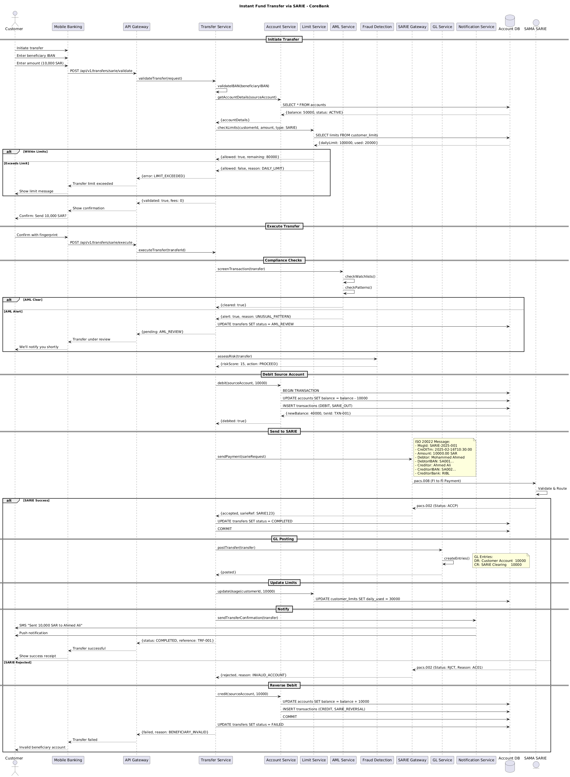

5.2. Flow Description
  - Initiate Transfer
The flow begins with the customer initiating the transfer through the mobile banking application. The customer provides the beneficiary's IBAN and the amount to transfer. The mobile banking application sends a POST request to the API Gateway to validate the transfer. The API Gateway then forwards the validation request to the Transfer Service.
Mobile App internally performs: validateIBAN(beneficiaryIBAN)
The Transfer Service internally validates the beneficiary's IBAN. Next, it retrieves the account details of the source account from the Account Service. The Account Service queries the Account DB to fetch the account details and returns them to the Transfer Service.
Account Service internally performs: getAccountDetails(sourceAccount)
The Account Service queries the Account DB to fetch the account details and returns them to the Transfer Service.
Transfer Service internally performs: validateIBAN(beneficiaryIBAN)
The Transfer Service internally validates the beneficiary's IBAN. Next, it checks the limits for the customer's daily limit. If the limits are exceeded, the Transfer Service returns a validation error to the API Gateway, which in turn shows a limit exceeded message to the customer.
API Gateway internally performs: validateTransfer(request)
The API Gateway validates the transfer request and returns a validated response to the Transfer Service. If the limits are within the allowed range, the Transfer Service sets the validated flag and returns a successful validation message to the API Gateway.
Mobile App internally performs: Show confirmation
The API Gateway shows a confirmation message to the customer, asking for fingerprint verification. The customer confirms the transfer, and the API Gateway sends a POST request to the Transfer Service to execute the transfer.
  - Execute Transfer
The customer confirms the transfer with a

5.3. APIs Contract Agreement
# | Source | Destination | API | Protocol | Request Parameters | Response Parameters
1 | API Gateway | Transfer Service | validateTransfer | REST | request | {error: LIMIT_EXCEEDED}
2 | Transfer Service | Account Service | getAccountDetails | REST | sourceAccount | {accountDetails}
3 | Account Service | Account DB | SELECT * FROM accounts | JDBC |  | {balance: 50000, status: ACTIVE}
4 | Transfer Service | Limit Service | checkLimits | REST | customerId, amount, type: SARIE | {allowed: true, remaining: 80000}
5 | Limit Service | Account DB | SELECT limits FROM customer_limits | JDBC |  | {dailyLimit: 100000, used: 20000}
6 | API Gateway | Transfer Service | executeTransfer | REST | transferId | {pending: AML_REVIEW}
7 | Transfer Service | AML Service | screenTransaction | REST | transfer | {cleared: true}
8 | Transfer Service | Account DB | UPDATE transfers SET status = AML_REVIEW | JDBC
9 | Transfer Service | Fraud Detection | assessRisk | REST | transfer | {riskScore: 15, action: PROCEED}
10 | Transfer Service | Account Service | debit | REST | sourceAccount, 10000 | {debited: true}
11 | Account Service | Account DB | BEGIN TRANSACTION | JDBC |  | {newBalance: 40000, txnId: TXN-001}
12 | Account Service | Account DB | UPDATE accounts SET balance = balance - 10000 | JDBC
13 | Account Service | Account DB | INSERT transactions | JDBC | DEBIT, SARIE_OUT
14 | Transfer Service | SARIE Gateway | sendPayment | REST | sarieRequest | {accepted, sarieRef: SARIE123}
15 | SARIE Gateway | SAMA SARIE | pacs.008 | REST | FI to FI Payment | Status: ACCP
16 | Transfer Service | Account DB | UPDATE transfers SET status = COMPLETED | JDBC
17 | Transfer Service | Account DB | COMMIT | JDBC
18 | Transfer Service | GL Service | postTransfer | REST | transfer | {posted}
19 | Transfer Service | Limit Service | updateUsage | REST | customerId, 10000
20 | Limit Service | Account DB | UPDATE customer_limits SET daily_used = 30000 | JDBC
21 | Transfer Service | Notification Service | sendTransferConfirmation | REST | transfer
22 | Notification Service | Customer | SMS "Sent 10,000 SAR to Ahmed Ali" | REST
23 | Notification Service | Customer | Push notification | REST
24 | SAMA SARIE | SARIE Gateway | pacs.002 | REST |  | Status: RJCT, Reason: AC01
25 | Transfer Service | Account Service | credit | REST | sourceAccount, 10000
26 | Account Service | Account DB | UPDATE accounts SET balance = balance + 10000 | JDBC
27 | Account Service | Account DB | INSERT transactions | JDBC | CREDIT, SARIE_REVERSAL
28 | Account Service | Account DB | COMMIT | JDBC
29 | Transfer Service | Account DB | UPDATE transfers SET status = FAILED | JDBC
[*] Indicates that the data element is optional

6. Personal Loan Disbursement

6.1. Sequence Diagram
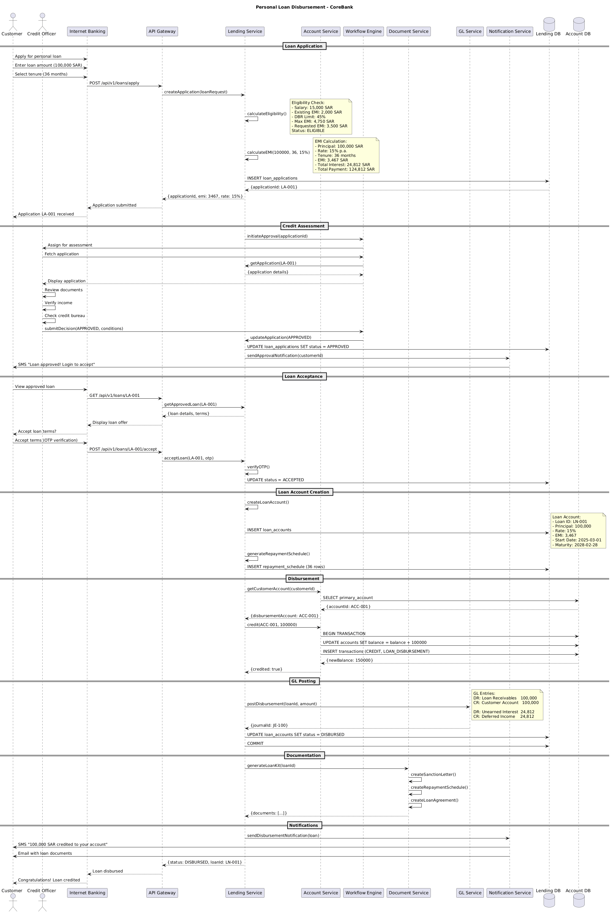

6.2. Flow Description
Loan Application
• Customer initiates the loan application process through the Internet Banking.
• The customer provides loan amount and tenure details.
• The Internet Banking sends a POST request to the API Gateway to apply for a loan.
• The API Gateway forwards the request to the Lending Service.
• The Lending Service internally performs an eligibility check, calculating the eligibility based on the customer’s salary, existing EMI, and other parameters.
• The Lending Service internally calculates the EMI based on the loan amount and tenure.
• The Lending Service inserts the loan application details into the Lending DB.
• The API Gateway responds to the Internet Banking with the application status.
• The Internet Banking displays the application status to the customer.
Credit Assessment
• The Lending Service initiates the credit assessment process through the Workflow Engine.
• The Workflow Engine assigns the assessment to a Credit Officer.
• The Credit Officer fetches the application details from the Workflow Engine.
• The Credit Officer internally performs a review of the documents, verifies the customer’s income, and checks the credit bureau.
• The Credit Officer submits a decision to the Workflow Engine.
• The Workflow Engine updates the application status in the Lending DB.
• The Workflow Engine sends an approval notification to the customer.
Loan Acceptance
• The customer accepts the loan terms and provides an OTP for verification.
• The Internet Banking sends a POST request to the API Gateway to accept the loan terms.
• The API Gateway forwards the request to the Lending Service.
• The Lending Service internally verifies the OTP and updates the application status.
• The API Gateway responds to the Internet Banking with the loan acceptance status.
Loan Account Creation
• The Lending Service internally creates the loan account and inserts the details into the Lending DB.
• The Lending Service generates the repayment schedule and inserts it into the Lending DB.
• The Lending Service internally creates the loan account and inserts it into the Account DB.
• The Lending Service internally creates the repayment schedule and inserts it into the Account DB.
• The Lending Service internally credits the loan amount into the customer’s account and updates the Account DB.
• The Lending Service internally posts the disbursement to the GL DB.
GL Posting
• The Lending Service internally posts the disbursement to the GL DB, creating GL entries for Loan Receivables and Unearned Interest.
• The Lending Service internally updates the loan account status in the Lending DB.
• The Lending Service internally commits the transaction to the Lending DB.
Documentation
• The Lending Service internally generates the loan kit, including the sanction letter, repayment schedule, and loan agreement.
• The Lending Service internally creates the loan kit and sends it to the Document Service.
• The Document Service creates the loan kit and sends it to the customer.
Notifications
• The Lending Service internally sends a disbursement notification to the customer via the Notification Service.
• The Notification Service sends a SMS and an email to the customer with the loan documents.
Each step in this flow is handled internally by the respective systems, ensuring that the loan application, assessment, acceptance, account creation, disbursement, GL posting, and documentation are processed correctly and securely. The flow is protected by various internal processing steps and conditions, ensuring that each

6.3. APIs Contract Agreement
# | Source | Destination | API | Protocol | Request Parameters | Response Parameters
1 | Internet Banking | API Gateway | POST /api/v1/loans/apply | REST |  | Application submitted
2 | API Gateway | Lending Service | createApplication | REST | loanRequest | {applicationId, emi: 3467, rate: 15%}
3 | Lending Service | Lending DB | INSERT loan_applications | JDBC |  | {applicationId: LA-001}
4 | Lending Service | Workflow Engine | initiateApproval | REST | applicationId
5 | Workflow Engine | Credit Officer | Assign for assessment | REST
6 | Workflow Engine | Lending Service | getApplication | REST | LA-001 | {application details}
7 | Workflow Engine | Lending Service | updateApplication | REST | APPROVED
8 | Lending Service | Lending DB | UPDATE loan_applications SET status = APPROVED | JDBC
9 | Lending Service | Notification Service | sendApprovalNotification | REST | customerId
10 | Notification Service | Customer | SMS "Loan approved! Login to accept" | REST
11 | Internet Banking | API Gateway | GET /api/v1/loans/LA-001 | REST |  | Display loan offer
12 | API Gateway | Lending Service | getApprovedLoan | REST | LA-001 | {loan details, terms}
13 | Internet Banking | API Gateway | POST /api/v1/loans/LA-001/accept | REST |  | Loan disbursed
14 | API Gateway | Lending Service | acceptLoan | REST | LA-001, otp | {status: DISBURSED, loanId: LN-001}
15 | Lending Service | Lending DB | UPDATE status = ACCEPTED | JDBC
16 | Lending Service | Lending DB | INSERT loan_accounts | JDBC
17 | Lending Service | Lending DB | INSERT repayment_schedule | JDBC | 36 rows
18 | Lending Service | Account Service | getCustomerAccount | REST | customerId | {disbursementAccount: ACC-001}
19 | Account Service | Account DB | SELECT primary_account | JDBC |  | {accountId: ACC-001}
20 | Lending Service | Account Service | credit | REST | ACC-001, 100000 | {credited: true}
21 | Account Service | Account DB | BEGIN TRANSACTION | JDBC |  | {newBalance: 150000}
22 | Account Service | Account DB | UPDATE accounts SET balance = balance + 100000 | JDBC
23 | Account Service | Account DB | INSERT transactions | JDBC | CREDIT, LOAN_DISBURSEMENT
24 | Lending Service | GL Service | postDisbursement | REST | loanId, amount | {journalId: JE-100}
25 | Lending Service | Lending DB | UPDATE loan_accounts SET status = DISBURSED | JDBC
26 | Lending Service | Lending DB | COMMIT | JDBC
27 | Lending Service | Document Service | generateLoanKit | REST | loanId | {documents: [...]}
28 | Lending Service | Notification Service | sendDisbursementNotification | REST | loan
29 | Notification Service | Customer | SMS "100,000 SAR credited to your account" | REST
30 | Notification Service | Customer | Email with loan documents | REST
[*] Indicates that the data element is optional

7. Appendix

7.1. Solution Architecture Reference Documents
# | Name | File
1 | BRD | Refer to Latest BRD Attached to JIRA Ticket

